Paper Title* (use style: *paper title*)

*Note: Sub-titles are not captured in Xplore and should not be used

line 1: 1st Given Name Surname   
line 2: *dept. name of organization   
(of Affiliation)*  
line 3: *name of organization   
(of Affiliation)*line 4: City, Country  
line 5: email address or ORCID

line 1: 4th Given Name Surname  
line 2: *dept. name of organization*  
*(of Affiliation)*  
line 3: *name of organization   
(of Affiliation)*line 4: City, Country  
line 5: email address or ORCIDline 1: 2nd Given Name Surname  
line 2: *dept. name of organization   
(of Affiliation)*  
line 3: *name of organization   
(of Affiliation)*line 4: City, Country  
line 5: email address or ORCID

line 1: 5th Given Name Surname  
line 2: *dept. name of organization   
(of Affiliation)*  
line 3: *name of organization   
(of Affiliation)*line 4: City, Country  
line 5: email address or ORCIDline 1: 3rd Given Name Surname  
line 2: *dept. name of organization   
(of Affiliation)*  
line 3: *name of organization   
(of Affiliation)*line 4: City, Country  
line 5: email address or ORCID

line 1: 6th Given Name Surname  
line 2: *dept. name of organization   
(of Affiliation)*  
line 3: *name of organization   
(of Affiliation)*line 4: City, Country  
line 5: email address or ORCID

*Abstract*—In this paper, a highly compact wideband monopole antenna of the dimensions $20×20{mm}^{2}$ is presented. The proposed antenna configuration has a simplified design in which the ground plane as well as the radiating patch are on the same plane. This design renders one side of the substrate consummately empty resulting in an overall design which is more facile to fabricate. It is excited by a lumped port. The proposed antenna configuration has a fractional bandwidth of 40.56% and an operational bandwidth of (4.3-6.45GHz). It has linearly increasing gain over its entire operational bandwidth. This antenna is intended to be used for WLAN, WiMax and satellite bands of range corresponding to 4.70-6.19 GHz, 5.5-5.7 GHz and 5-6 GHz. Proposed antenna is simulated using HFSS.

Keywords—component, formatting, style, styling, insert (key words)

# Introduction

The compact multiband antenna has earned momentous consideration in the antenna design due to its fascinating operational characteristics. As, the size of a wireless device is declining day by day, it becomes very crucial to design a compact antenna that can accommodate the prerequisites of wireless end terminal devices [1-2]. A monopole antenna is extensively used because of its lightweight, low profile and uncomplicated antenna structure with dependability, mobility and good capability [2]. They are most advisable for aerospace and mobile functions. Recently, the wideband communication systems are scrutinized to satisfy the appeal for high data transmission rate, low initial and operation cost and low power consumption. An essential component of the wideband communication systems, wide band antennas have captivated symbolic analysis activity in the latter years. The threats faced by viable wideband antenna design incorporate wide impedance matching, radiation dependability, slender profile, tight size and lesser cost [3].

Though, the wideband wireless communication systems have established aspects and benefits. There are also few technical problems to be clarified. The wideband antenna should envelop the assigned 7500 MHz of spectrum to completely utilize it [4]. However, there are some antennas suggested for wideband applications. All of them have wide impedance band width and acceptable radiation pattern, one of them is monopole antenna. The monopole antennas are used for wideband communications due to their fascinating features of determining wide bandwidth, simple structure, and omnidirectional radiation pattern [5]. The broadband monopole antenna is vertically polarized and has low angle radiation pattern and is used for short range circuits by ground wave and medium range circuits by sky wave

Recently, wideband communication system has drawn remarkable research interest due to their advantage such as, low power consumption, high date rate, compact system size etc. [6]. One important component to these systems which plays an important role in its functionalities is a wideband antenna. Antenna with fractional bandwidth greater than 20% of the center frequency is known as a wideband antenna. Literature reports various wideband antennas for wireless applications [7-12]. In [7], a broadband antenna operating at dual resonance was designed by utilizing a U-shaped stub inset at the middle of the slotted antenna. In [8], authors have used the concept of vertical polarization and a unit of broadband transmitting antenna was designed. In [9], a truncated circular patch was proposed to obtain wide bandwidth from 2.3-6GHz. In [10], a H-PIFA (H-shaped Planar Inverted-F was proposed to obtain the bandwidth range from 470-3800MHz. In [11], a wideband antenna with shaped beams to obtain the wide bandwidth range from 470-706MHz. In [12], authors have designed a wideband mushroom antenna by using Frequency Selective Surface technique to obtain the bandwidth range from 4.72-6.04GHz. However, all the aforementioned design suffers from the constraint of large size, less gain and less radiation efficiency. The wideband antenna design proposed in this paper eliminate the constraint of large size, gain and radiation efficiency as compared to the antenna proposed in [6-12].

The main contributions of the paper are as follows:

* The wide bandwidth in the antenna is accomplished using simple slotted radiating patch.
* The antenna has acceptable gain, compact size and stable radiation performances in entire operating bandwidth.

# Methodology

An antenna which has a smaller footprint but has the same or better bandwidth, gain and reflection coefficient is more desirable in today’s world. In order to fulfil the criteria mentioned in the above the designing of the antenna is carried out in three steps as shown in Fig. 1.In “Step 1” of antenna design a monopole antenna with radiating patch and partial ground both in same plane is constructed. The radiating patch has a feed line is excited by a lumped port. “Step 2” of antenna design involved cutting a slot in the ground plane in order to attain a reflection coefficient which is less than -10db for a substantial bandwidth. It also involved making a slot in the radiating patch to increase the bandwidth of the antenna. “Step 3” shows the final design of the antenna. Steps were made in the radiating patch to increase the bandwidth. Fig. 2 shows comparison of reflection coefficients of different steps for the design of antenna. The reduction in size of the radiating patch of the antenna is done by making slots in it. The final antenna has a wide operational bandwidth of 4.3-6.45GHz. The resonant frequency of the proposed antenna can be calculated as:

$$Maximum Length of a wideband monopole=\frac{λ}{4}=\frac{c}{4f_{r}}$$

Thus,

$$f_{o}=\frac{C}{4× (maxm. length)}≅5.3 GHz$$

where $c$ is the speed of light in free space ($3×{10}^{11}mm/sec⁡)$. The final structure of the antenna is shown in Fig. 3, the fabricated antenna of the proposed cinfiguration is shown inn Fig. 4 and the detailed dimensions of the monopole antenna are given in Table 1.

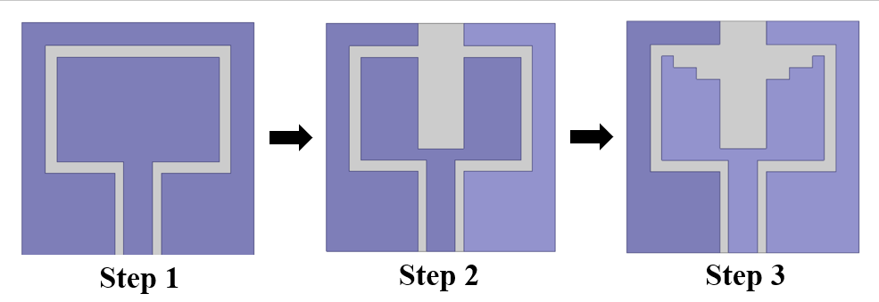

Fig. 1 Antenna design evolution

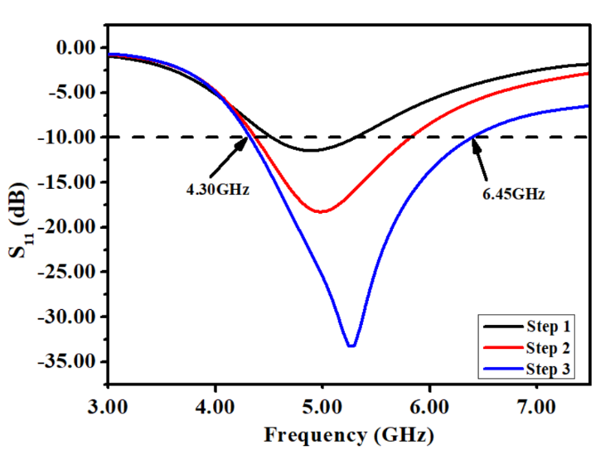

Fig. 2 Comparison of Reflection Coefficients of different steps involved in antenna design

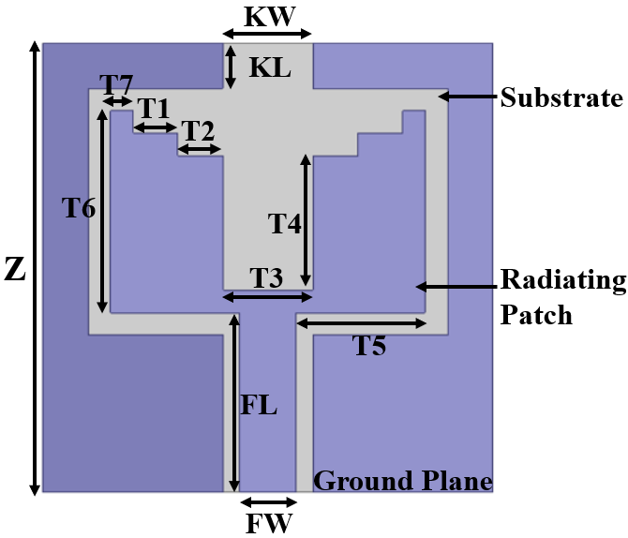

Fig. 3 Proposed antenna structure front plane

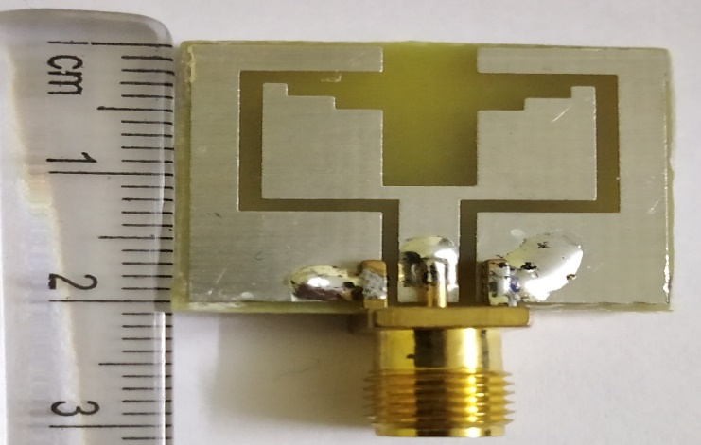

Fig. 4 Top view of the fabricated antenna

Table 1: Dimensions of the proposed antenna

|  |  |
| --- | --- |
| Parameter | Dimensions(mm) |
| T1 | 2 |
| T2 | 2 |
| T3 | 4 |
| T4 | 6 |
| T5 | 5.75 |
| T6 | 9 |
| T7  FL | 1  8 |
| FW | 2 |
| KL | 4 |
| KW | 4 |
| Z | 20 |

# Parametric Analysis

In order to optimize the dimensions of the antenna for proper operational execution, parametric analysis is carried out. The analysis is executed by varying one dimension of the antenna while keeping other dimensions constant. The first dimension to be analyzed for optimization is the width of the feed line (FW). The width of the feed line (FW) is first decreased by 0.75mm and then increased by 0.75mm. It is visible from Fig. 5 that the S11 performances are altered by changing FW.

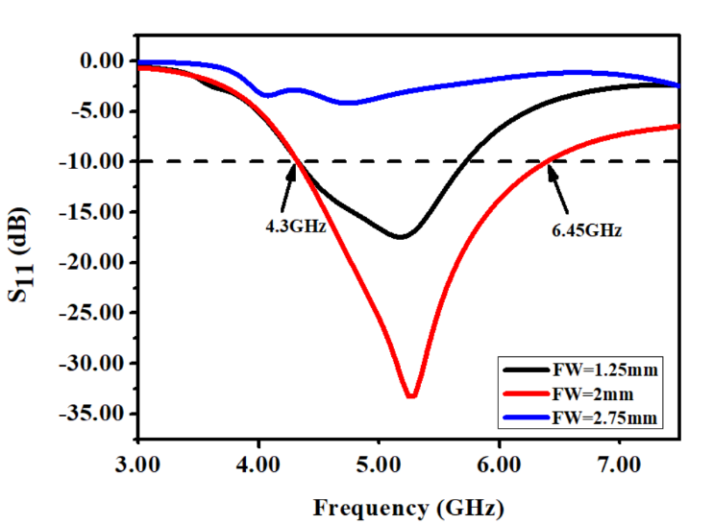

Fig. 5 Analysis of FW

Similarly, parametric analysis is done for the width of the slot of the ground plane (KW). It is clearly visible from Fig. 6 that best performance (i.e. S11<-10dB) is obtained when KW=4mm.

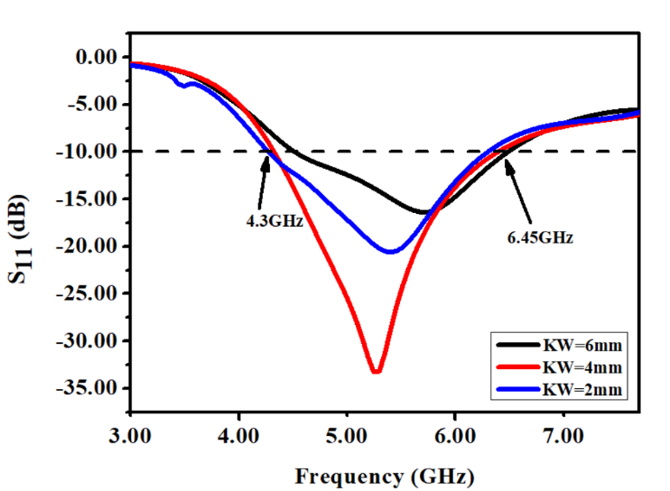

Fig. 6 Analysis of KW

The analysis for the central U-shaped slot’s width (T3) is done to find its optimum dimension. It is clearly visible in Fig. 7 that the best performance (i.e. wider bandwidth) is obtained when T3=4mm.

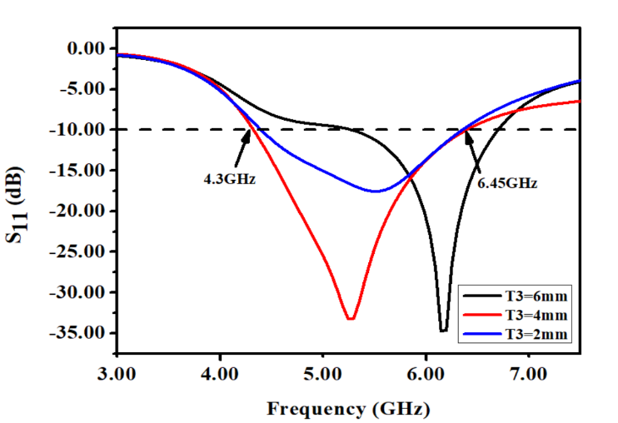

Fig. 7 Analysis of T3

# Results

The proposed wideband antenna is simulated using HFSS. The substrate used for the simulation is FR4, with the following specifications: h=1.6mm, $ε_{r}=4.4$. The antenna has a fractional bandwidth of 40.56% (4.3-6.45GHz). The simulated result for S11 are presented in Fig. 8.

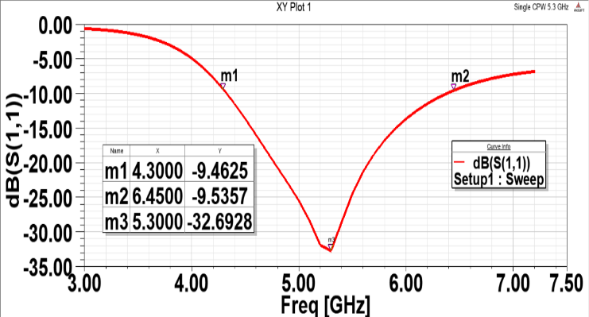

Fig. 8 Simulated S11 plot of the proposed antenna

The antenna is inductive in nature with input impedance of 47.93+j3.03 at the resonance frequency of 5.3GHz. The input impedance is shown in Fig. 9.

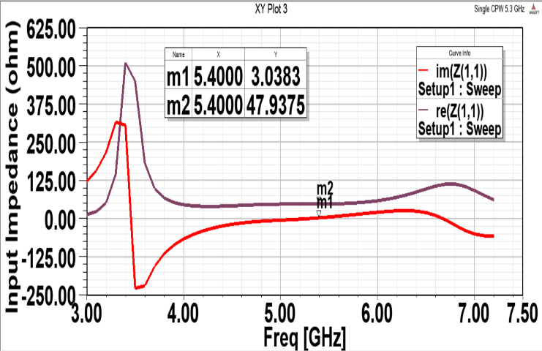

Fig. 9 Simulated plot of Input Impedance of the proposed antenna

The peak gain of the antenna is presented in Fig. 10. It is visible from the plot that gain is increasing linearly throughout the entire operational bandwidth of the antenna.

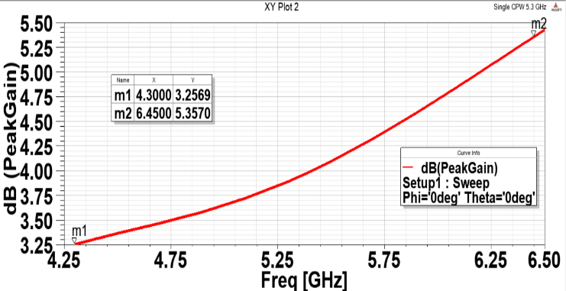

Fig. 10 Simulated plot of Peak Gain of the proposed antenna

The 2D radiation pattern of the proposed antenna is presented in Fig. 11. It is visible from the plot that the antenna is displaying a bidirectional pattern at $φ={90}^{o}$ (E-plane), and omnidirectional pattern at $φ=0^{o}$ (H-plane).

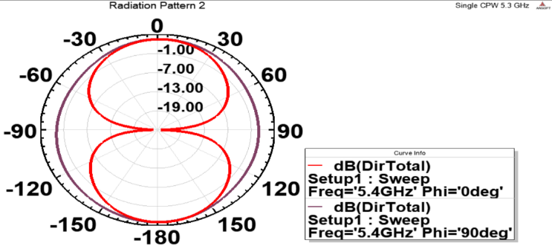

Fig. 11 Simulated radiation pattern of the proposed antenna

After fabrication, the S11 of the antenna is measured in order to determine accuracy of the simulations and Fig. 12 depicts that the measured S11 of the fabricated antenna closely mimics the simulated S11 of the designed antenna.

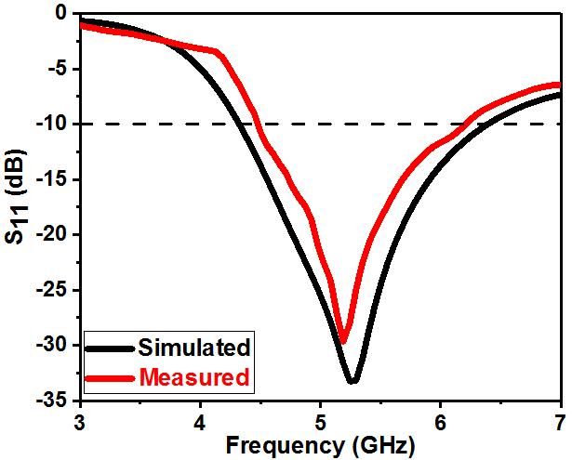

Fig. 12 Measured and simulated S11 of the proposed antenna configuration

Table 2: Comparison of the proposed antenna configuration with other wide-band antennas discussed in literature review; DS is the total area of the antenna, BH is the operating bandwidth of the antenna, FE is the frequency range of the antenna and GN is the gain of antenna

|  |  |  |  |  |
| --- | --- | --- | --- | --- |
| Ref No. | DS() | BH(GHz) | FE(GHz) | GN(dB) |
| 7 | $$75×75{mm}^{2}$$ | 2.6GHz,  0.8GHz | 2.4-5GHz,  5.150-5.950GHz | 3.7 dBi,  4.5dBi |
| 8 | $$85×35{mm}^{2}$$ | 0.461GHz | 0.451-0.912GHz | 1.52-1.7dBi |
| 9 | $$40×33{mm}^{2}$$ | 3.7GHz | 2.3-6GHz | 0-4.5dB |
| 10 | $$225×30{mm}^{2}$$ | 0.500GHz | 3.3-3.8GHz | 2.72-3.6dBi |
| 11 | $$450×450{mm}^{2}$$ | 0.236GHz | 0.470-0.706GHz | 4.2dBi |
| 12 | $$36×32{mm}^{2}$$ | 1.32GHz | 4.72-6.04GHz | 5dB |
| Proposed Antenna | $$20×20{mm}^{2}$$ | 2.1GHz | 4.3GHz-6.45GHz | 5.5dB |

# Conclusion

A compact monopole antenna with enhanced bandwidth is proposed, fabricated and measured. The size of antenna is $20×20 {mm}^{2}$ with a step slotted patch. The antenna is applicable for most of WLAN, WiMax and satellite bands of range corresponding to 4.70-6.19 GHz, 5.5-5.7 GHz and 5-6 GHz. The antenna excited a -10dB bandwidth of 2.1 GHz ranging from 4.3GHz to 6.45GHz. This simple designed and low-cost antenna is very useful in the field of wireless communication. Moreover, the measured results match with the simulated results states that the antenna proposed is promising candidate for WLAN, WiMax applications.

##### References

1. B. K. Subhash, K. Abhishek, A. Tanweer, S. H. Bharathi and R. C. Biradar, "A Compact Audi-Shaped Slotted Multiband Antenna for WiMAX/WLAN/X-band Applications," 2018 Second International Conference on Advances in Electronics, Computers and Communications (ICAECC), Bangalore, 2018, pp. 1-6.
2. J. Kumar and S. S. Shirgan, "Compact Partial Ground Plane 1x2 Patch Antennas," 2014 International Conference on Computational Intelligence and Communication Networks, Bhopal, 2014, pp. 33-37.
3. R. Fotedar, P. Garia, R. Saini, A. Vidyarthi and R. Gowri, "Performance Analysis of Microstrip Antennas Using Different Shapes of Patch at 2.4 GHz," 2015 Second International Conference on Advances in Computing and Communication Engineering, Dehradun, 2015, pp. 374-377.
4. Wei Tong and Z. R. Hu, "A CWP fed circular monopole antenna for ultra wideband wireless communications," 2005 IEEE Antennas and Propagation Society International Symposium, Washington, DC, 2005, pp. 528-531 vol. 3A.
5. S. Ghosh and B. K. Sarkar, "Design of microstrip crossed monopole antenna for ultra wideband communication Microstrip crossed monopole for ultra wideband communication," 2012 Annual IEEE India Conference (INDICON), Kochi, 2012, pp. 499-502.
6. Liu, H., Yin, C., Gao, W., & Sun, Y. (2015). Optimization and Design of Wideband Antenna Based on Q Factor. *International Journal of Antennas and Propagation*, *2015*.
7. Wu, J. W., Hsiao, H. M., Lu, J. H., & Chang, S. H. (2004). Dual broadband design of rectangular slot antenna for 2.4 and 5 GHz wireless communication. *Electronics Letters*, *40*(23), 1461-1463.
8. C. -. Huang, B. -. Jeng and C. -. Yang, "Wideband monopole antenna for DVB-T applications," in Electronics Letters, vol. 44, no. 25, pp. 1448-1450, 4 December 2008.
9. Kurniawan, A., &Mukhlishin, S. (2013). Wideband antenna design and fabrication for modern wireless communications systems. *Procedia Technology*, *11*, 348-353.
10. R. Caso, A. D'Alessandro, A. A. Serra, P. Nepa and G. Manara, "Wideband integrated H-PIFA antenna for DVB-T and WiMAX applications," 2011 IEEE International Symposium on Antennas and Propagation (APSURSI), Spokane, WA, 2011, pp. 1394-1396.
11. S. -. Zhou, B. -. Sun, Y. -. Wei and Q. -. Liu, "Low profile wideband antenna with shaped beams for indoor DVB-H applications," in Electronics Letters, vol. 45, no. 23, pp. 1151-1152, November 2009.
12. Y. Jia, Y. Liu, H. Wang, K. Li and S. Gong, "Low-RCS, High-Gain, and Wideband Mushroom Antenna," in IEEE Antennas and Wireless Propagation Letters, vol. 14, pp. 277-280, 2015.